**7**

**Energy of a System**

|  |
| --- |
| **CHAPTER OUTLINE** |

7.1 Systems and Environments

7.2 Work Done by a Constant Force

7.3 The Scalar Product of Two Vectors

7.4 Work Done by a Varying Force

7.5 Kinetic Energy and the Work-Kinetic Energy Theorem

7.6 Potential Energy of a System

7.7 Conservative and Nonconservative Forces

7.8 Relationship Between Conservative Forces and Potential Energy

7.9 Energy Diagrams and Equilibrium of a System

* An asterisk indicates a question or problem new to this edition.

|  |
| --- |
| **SOLUTIONS TO THINK-PAIR-SHARE AND ACTIVITIES** |

**\*TP7.1 Conceptualize** When a force is applied to stretch a spring, that force is the same everywhere in the spring, just like the tension is the same everywhere in a string. Therefore, a given force is associated with a given change in the separation distance between adjacent coils of the spring, regardless of how many coils are in the spring.

**Categorize** We categorize the first part of the problem as one in which we must use Equation 7.9 to determine how the force constant of a spring varies as we change the number of free coils.

**Analyze** (a) Imagine applying a force of magnitude *F* to the unclamped spring. The force constant is then found from Equation 7.9:

 (1)

where we are considering only magnitudes, so we have dropped the negative sign. Now imagine applying that same force to the clamped spring, with *N’* coils free. The force constant of the free part of the spring is then also found from Equation 7.9:

 (2)

As discussed under “Conceptualize,” the same force will cause the same separation distance between coils. But only part of the clamped spring can expand. Because we have the same coil separation distance in the clamped and unclamped springs, but different numbers of coils free to expand, we see that the relationship between the lengths of expansion for a given force is

 (3)

Substituting Equation (3) into Equation (2) gives us

 (4)

Substituting from Equation (1), we find

 (5)

(b) From Equation (5), we know that the spring constant is



Therefore, because the force constant is twice that for the unclamped spring, in the expression for the differential work done, *dW* = *Fdx*, the force required for each extension *dx* is twice as much as for the unclamped spring. Each spring is extended over the same total distance *x*, so the work done is 2*W*.

**Finalize** Notice that the key to solving this problem is to recognize that a given force applied to the spring is related to a given separation distance between coils of the spring.

*Answers:* (a)  (b) 2*W*

**\*TP7.2** (a) No; for example, compare 30 mi/h and 60 mi/h. The stopping distance of 201.7 ft is not twice 50.4 ft. Other pairs of speeds related by a factor of 2 show the same thing.

(b) A straight graph of stopping distance versus speed is shown below. 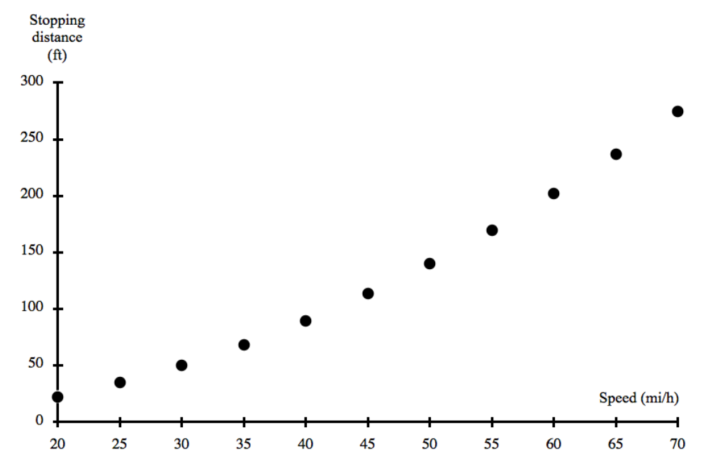

The graph is clearly not linear. We can check to see if the graph represents a power-law dependence *x* ∝ *vn* by graphing the logarithm of the stopping distance against the logarithm of the speed. We obtain the graph below.

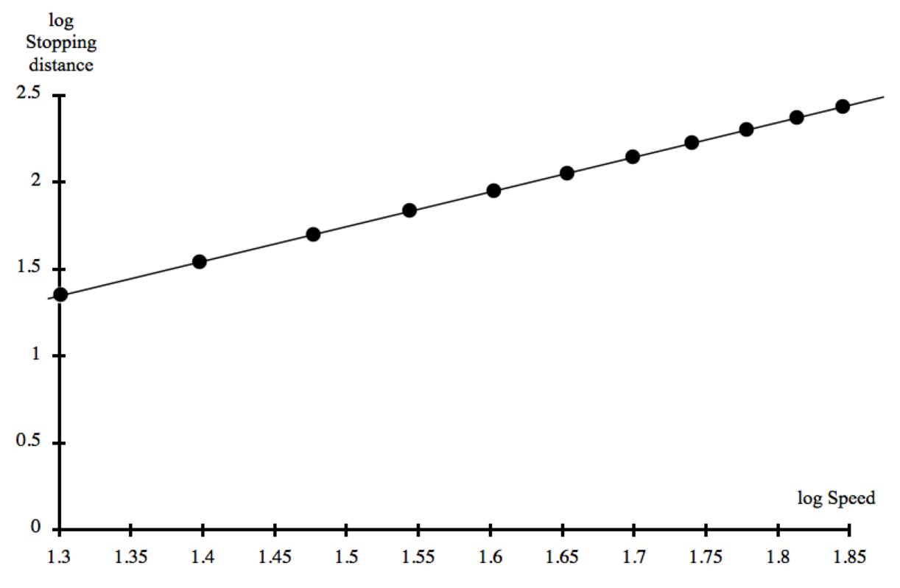

The straight-line nature of this graph shows that there is indeed a power-law relationship between the stopping distance and the speed. Analysis shows that the slope of the line is *n* = 2, so the relationship is *d* ∝ *v*2. You could also graph *d* versus *v*2, resulting in a straight line, showing that *n* = 2.

(c) From the work–kinetic energy, theorem, *W* = ∆*K*, where work *W* on the left depends linearly on the distance *d* over which the force acts to stop the car. The change ∆*K* in kinetic energy on the right of the equation, noting that the car begins from rest, depends linearly on the square of the speed *v* of the car. Therefore, *d* ∝ *v*2. Use Equation 2.17 to show that we expect *d* ∝ *v*2 from an assumption that the acceleration of the car is constant.

*Answers:* (a) no (b) *n* = 2. (c) Answers will vary.

|  |
| --- |
| **SOLUTIONS TO END-OF-CHAPTER PROBLEMS** |

Section 7.2 Work Done by a Constant Force

P7.1 (a) The 35-N force applied by the shopper makes a 25° angle with the displacement of the cart (horizontal). The work done on the cart by the shopper is then



(b) The force exerted by the shopper is now completely horizontal and will be equal to the friction force, since the cart stays at a constant velocity. In part (a), the shopper’s force had a downward vertical component, increasing the normal force on the cart, and thereby the friction force. Because there is no vertical component here, the friction force will be less, and the  than before.

(c) Since the horizontal component of the force is less in part (b), the work performed by the shopper on the cart over the same 50.0-m distance is  as in part (b).

P7.2 Assuming the mass is lifted at constant velocity, the total upward force exerted by the two men equals the weight of the mass: Ftotal = mg = (653.2 kg)(9.80 m/s2) = 6.40 × 103 N. They exert this upward force through a total upward displacement of 96 inches (4 inches per lift for each of 24 lifts). The total work would then be

*W*total = (6.40 × 103 N)[(96 in)(0.025 4 m/1 in)] = 

P7.3 (a) The work done by a constant force is given by



where  is the angle between the force and the displacement of the object. In this case, *F* = –*mg* and  giving

W = (281.5 kg)(9.80 m/s2)[(17.1 cm)(1 m/102 cm)] = 

(b) If the object moved upward at constant speed, the net force acting on it was zero. Therefore, the magnitude of the upward force applied by the lifter must have been equal to the weight of the object:

F = mg = (281.5 kg)(9.80 m/s2) = 2.76 × 103 N = 

P7.4 **METHOD ONE**

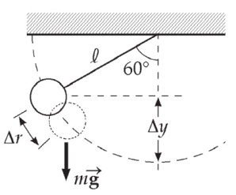 Let *φ* represent the instantaneous angle the rope makes with the vertical as it is swinging up from   
*φ*i = 0 to *φ*f = 60º. In an incremental bit of motion from angle *φ* to *φ* + d*φ*, the definition of radian measure implies that  The angle   
*θ*  between the incremental displacement and the force of gravity is *θ* = 90º + *φ*. Then

**ANS. FIG. P7.4**

cos *θ* = cos (90º + *φ*) = –sin *φ*

The work done by the gravitational force on Spiderman is



METHOD TWO

The force of gravity on Spiderman is mg = (80 kg)(9.8 m/s2) = 784 N down. Only his vertical displacement contributes to the work gravity does. His original y coordinate below the tree limb is –12 m. His final y coordinate is (–12.0 m) cos 60.0º = –6.00 m. His change in elevation is   
–6.00 m – (–12.0 m). The work done by gravity is



**Section 7.3 The Scalar Product of Two Vectors**

P7.5   


And since  and 



P7.6 A = 5.00; B = 9.00; θ = 50.0º



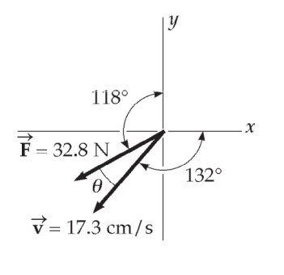P7.7 We must first find the angle between the two   
vectors. It is

*θ* = (360º – 132º) – (118º + 90.0º)   
= 20.0º

Then

**ANS. FIG. P7.7**



or 

P7.8 (a) 





(b) 





(c) 





**Section 7.4 Work Done by a Varying Force**

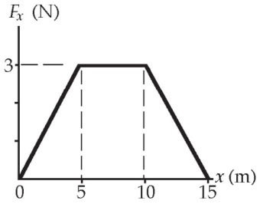P7.9 We use the graphical representation of the definition of work. *W* equals the area under the force-displacement curve. This definition is still written  but it is computed geometrically by identifying triangles and rectangles on the graph.

**ANS. FIG. P7.9**

(a) For the region 0 ≤ *x* ≤ 5.00 m,



(b) For the region 5.00 ≤ *x* ≤ 10.0, 

(c) For the region 10.00 ≤ x ≤ 15.0, 

(d) For the region 0 ≤ x ≤ 15.0, *W* = (7.50 + 7.50 + 15.0) J = 

P7.10  *kx* = *ma*

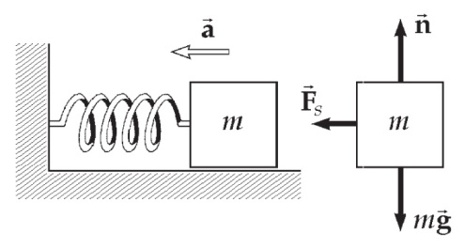 

ANS. FIG. P7.10

P7.11 When the load of mass *M* = 4.00 kg is hanging on the spring in equilibrium, the upward force exerted by the spring on the load is equal in magnitude to the downward force that the Earth exerts on the load, given by *w* = *Mg*. Then we can write Hooke’s law as *Mg* = +*kx*. The spring constant, force constant, stiffness constant, or Hooke’s-law constant of the spring is given by



(a) For the 1.50-kg mass,



(b) Work

P7.12 

P7.13 **Conceptualize** As a tray is removed, there is less force on the springs. Therefore, the springs will stretch out, pushing the remaining stack of trays upward. We want to choose springs such that removing one tray will cause the springs to stretch by the thickness of one tray.

**Categorize** The dispenser can be modeled as four identical springs, each supporting one-fourth of the weight of the trays. We learned about such systems in this chapter.

**Analyze** From Equation 7.9, the magnitude of the force on the stack of trays is

 (1)

We will change the force by removing a tray. Considering Equation (1) for a change in the force,

 (2)

Solving Equation (2) for the spring constant,

 (3)

The change in force on each of the four springs when a tray is removed is one-fourth the weight *mg* of the tray. We wish the extension of the spring when a tray is removed to be the thickness *d* of a tray. Therefore, the required spring constant is



Substituting numerical values,



**Finalize** The custodian should choose four identical springs, each with spring constant 316 N/m. Furthermore, each spring should be able to compress over a length range equal to *Nd*, where *N* is the maximum number of trays to be stored in the dispenser and *d* is the thickness of one tray. Notice that the rectangular dimensions of the tray are not required for the answer.

*Answer:* Each spring should have a spring constant of 316 N/m.

P7.14 The spring exerts on each block an outward force of   
magnitude





Take the +x direction to the right. For the light block on the left, the vertical forces are given by

ANS. FIG.P7.14

F*g* = mg = (0.250 kg)(9.80 m/s2) = 2.45 N

and 

so 

Similarly, for the heavier block,

n = Fg = (0.500 kg)(9.80 m/s2) = 4.90 N

(a) For the block on the left,

 –0.308 N = (0.250 kg)a



For the heavier block,

+0.308 N = (0.500 kg)a



(b) For the block on the left, fk = μkn = 0.100(2.45 N) = 0.245 N.



–0.308 N + 0.245 N = (0.250 kg)*a* .

For the block on the right, fk = μkn = 0.490 N. The maximum force of static friction would be larger, so no motion would begin and the acceleration is .

(c) Left block: fk = 0.462(2.45 N) = 1.13 N. The maximum static friction force would be larger, so the spring force would produce no motion of this block or of the right-hand block, which could feel even more friction force. For both, 

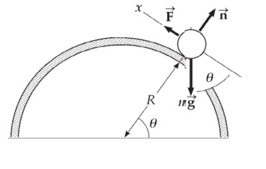P7.15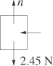 (a) The radius to the object makes angle *θ* with the horizontal. Taking the *x* axis in the direction of motion tangent to the cylinder, the object’s weight makes an angle *θ* with the –*x* axis. Then,

**ANS. FIG. P7.15**



(b) 

We use radian measure to express the next bit of displacement as dr = *Rdθ* in terms of the next bit of angle moved through:



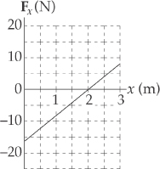P7.16 The force is given by *Fx* = (8*x* –16) N.

(a) See ANS. FIG. P7.16 to the right.

ANS. FIG. P7.16

(b) 

P7.17 (a)

|  |  |  |  |
| --- | --- | --- | --- |
| *F* (N) | *L* (mm) | *F* (N) | *L* (mm) |
| 0.00 | 0.00 | 12.0 | 98.0 |
| 2.00 | 15.0 | 14.0 | 112 |
| 4.00 | 32.0 | 16.0 | 126 |
| 6.00 | 49.0 | 18.0 | 149 |
| 8.00 | 64.0 | 20.0 | 175 |
| 10.0 | 79.0 | 22.0 | 190 |

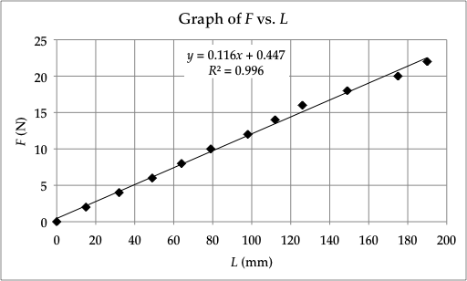

ANS FIG. P7.17(a)

(b) By least-squares fitting, its slope is 0.116 N/mm = 

(c) To draw the straight line we use all the points listed and also the origin. If the coils of the spring touched each other, a bend or nonlinearity could show up at the bottom end of the graph. If the spring were stretched “too far,” a nonlinearity could show up at the top end. But there is no visible evidence for a bend in the graph near either end.

(d) In the equation F = kx, the spring constant k is the slope of the   
F-versus-x graph.



(e) F = kx = (116 N/m)(0.105 m) = 

P7.18 (a) We find the work done by the gas on the bullet by integrating the function given:







(b) Similarly,



(c) 

P7.19   


P7.20 We read the coordinates of the two specified points from the graph as

*a* = (5 cm, –2 N) and *b* = (25 cm, 8 N)

We can then write u as a function of v by first finding the slope of the curve:



The *y* intercept of the curve can be found from *u* = *mv* + *b,* where   
*m* = 0.5 N/cm is the slope of the curve, and *b* is the *y* intercept.Plugging in point *a*, we obtain



Then,



(a) Integrating the function above, suppressing units, gives



(b) Reversing the limits of integration just gives us the negative of the quantity:



(c) This is an entirely different integral. It is larger because all of the area to be counted up is positive (to the right of v = 0) instead of partly negative (below u = 0).



**Section 7.5 Kinetic Energy and the Work-Kinetic Energy Theorem**

**P7.21**  (a) 

(b) 

(c) 

**P7.22** (a)  (area under curve from x = 0 to x = 5.00 m)



(b)  (area under curve from x = 0 to x = 10.0 m)



(c)  (area under curve from x = 0 to x = 15.0 m)



P7.23 Consider the work done on the pile driver from the time it starts from rest until it comes to rest at the end of the fall. Let d = 5.00 m represent the distance over which the driver falls freely, and h = 0.12 the distance it moves the piling.



so 

Thus,



The force on the pile driver is 

P7.24 (a) 



(b) 





(c) 

(d) 



P7.25 (a) 



(b) As shown in part (a), the net work performed on the bullet is 

(c) 

(d) 

(e) 

(f) 

P7.26 **Conceptualize** Figure P7.26 helps you to visualize the physical setup of the new game.

**Categorize** The spring will do work on the dart, providing it with kinetic energy according to the work–kinetic energy theorem. After the dart leaves the spring, it is a particle under constant acceleration.

**Analyze** The information about hanging the ten darts from the spring allows us to find the spring constant:

 (1)

where *m* is the mass of a single dart and *d* is the distance of extension of the spring when the ten darts hang from it.

Let’s apply the work–kinetic energy theorem to the time interval during which the spring is released from its compressed configuration and extends to its full length, while pushing the dart upward, and then the dart rises to its highest point. When the spring is extended to its full length, it is relaxed, so the upper end of the spring is identified as *xf* = 0, where the *f* subscript indicates this will be the *final* position of the end of the spring when the dart is launched. When the spring is fully compressed before launch, the *initial* position of the end of the spring is *xi*. We ignore for now the presence of the ceiling. Applying the work–kinetic energy theorem to the dart over this time interval,

 (2)

where we have noted that there is no change in kinetic energy because the dart is at rest at both the beginning and the end of the time interval. Substituting for the energies, using Equation 7.12 for the work done by the spring,



where we have defined *y* = *h* as the final position when the dart comes to rest relative to the initial position of the dart when the spring is compressed.

Solve Equation (3) for the height *h* of the dart and substitute from Equation (1):



Substitute numerical values, noting that the 5.00-cm spring can be compressed to a length of 1.00 cm:



Therefore, incorporating the fact that the initial position of the dart is 1.00 cm above the floor, the dart goes upward to a height of 81.0 cm above the floor. You are embarrassed because the dart goes upward less than one-third of the way to a standard 8-foot ceiling.

**Finalize** You have learned two lessons: (i) You need to find a stronger spring, and (ii) you need to test things out before presenting them to an audience!

*Answer:* The dart does not reach the ceiling.

P7.27 (a) K = mv2 = m(v*x*2 + v*y*2)

= (5.75 kg)[(5.00 m/s)2 + (–3.00 m/s)2] = 

(b) We know F*x* = ma*x* and F*y* = ma*y*. At t = 0, x*i* = y*i* = 0, and   
v*xi* = 5.00 m/s, v*yi* = –3.00 m/s; at t = 2.00 s, x*f* = 8.50 m, y*f* = 5.00 m.





F*x* = ma*x* = (5.75 kg)(–0.75 m/s2) = –4.31 N

F*y* = ma*y* = (5.75 kg)(5.50 m/s2) = 31.6 N



(c) We can obtain the particle’s speed at *t* = 2.00 s from the particle under constant acceleration model, or from the nonisolated system model. From the former,







From the nonisolated system model,



The work done by the force is given by



then,



which gives



P7.28 (a) As the bullet moves the hero’s hand, work is done on the bullet to decrease its kinetic energy. The average force is opposite to the displacement of the bullet:







(b) If the average force is constant, the bullet will have a constant acceleration and its average velocity while stopping is . The time required to stop is then



**Section 7.6 Potential Energy of a System**

P7.29 Use U = mgy, where y is measured relative to a reference level. Here, we measure y to be relative to the top edge of the well, where we take y = 0.

(a) *y* = 1.3 m: U = mgy = (0.20 kg)(9.80 m/s2)(1.3 m) = 

(b) *y* = –5.0 m: U = mgy = (0.20 kg)(9.80 m/s2)(–5.0 m) = 

(c) 

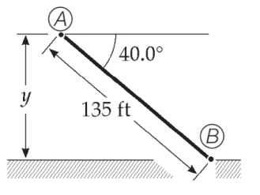P7.30 (a) With our choice for the zero level for   
potential energy of the car-Earth system   
when the car is at point 



**ANS. FIG. P7.30**

When the car is at point  the potential energy of the car-Earth system is given by

UA = *mgy*

where y is the vertical height above zero level. With 135 ft   
= 41.1 m, this height is found as:

*y* = (41.1 m) sin 40.0º = 26.4 m

Thus,



The change in potential energy of the car-Earth system as the car moves from  to  is



(b) With our choice of the zero configuration for the potential energy of the car-Earth system when the car is at point  we have . The potential energy of the system when the car is at point  is given by UB = mgy, where y is the vertical distance of point  below point  In part (a), we found the magnitude of this distance to be 26.5 m. Because this distance is now below the zero reference level, it is a negative number.

Thus,



The change in potential energy when the car moves from  to  is



**Section 7.7 Conservative and Nonconservative Forces**

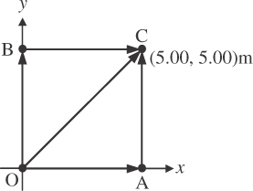P7.31 The gravitational force is downward:

*Fg* = *mg* = (4.00 kg)(9.80 m/s2) = 39.2 N

(a) Work along OAC = work along OA + work along AC



**ANS. FIG. P7. 30**

(b) W along OBC = W along OB + W along BC



(c) Work along OC = *F*g(OC) cos 135°



(d) 

P7.32 (a)  and if the force is constant, this can be written as





(b) 



The same calculation applies for all paths.

P7.33 In the following integrals, remember that



(a) The work done on the particle in its first section of motion is



and since along this path, *y* = 0, that means *W*OA = 0.

In the next part of its path, 

For *x* = 5.00 m, *W*AC = 125 J

and 

(b) Following the same steps, 

Since along this path, *x* = 0, that means *W*OB = 0.



Since *y* = 5.00 m, *W*BC = 50.0 J.



(c) 

Since x = y along OC, 

(d) 

(e) 

**Section 7.8 Relationship Between Conservative Forces and Potential Energy**

P7.34 We need to be very careful in identifying internal and external work on the book-Earth system. The first 20.0 J, done by the librarian on the system, is external work, so the system now contains an additional   
20.0 J compared to the initial configuration. When the book falls and the system returns to the initial configuration, the 20.0 J of work done by the gravitational force from the Earth is internal work. This work only transforms the gravitational potential energy of the system to kinetic energy. It does not add more energy to the system. Therefore, the book hits the ground with 20.0 J of kinetic energy. The book-Earth system now has zero gravitational potential energy, for a total energy of 20.0 J, which is the energy put into the system by the librarian.

P7.35 (a) For a particle moving along the *x* axis, the definition of work by a variable force is



Here *Fx* = (2*x* + 4) N, *xi* = 1.00 m, and *xf* = 5.00 m.

So



(b) The change in potential energy of the system is the negative of the internal work done by the conservative force on the particle: 

(c) 



P7.36 



Thus, the force acting at the point (*x, y*) is



P7.37 We use the relation of force to potential energy as the force is the negative derivative of the potential energy with respect to distance:





If A is positive, the positive value of radial force indicates a force of repulsion.

**Section 7.9 Energy Diagrams and Equilibrium of a System**

P7.38 (a) 

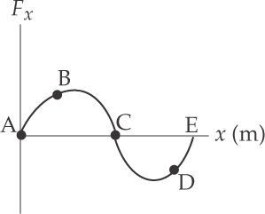 (b) 

(c) ANS. FIG. P7.38 shows the curve for *Fx* vs. *x* for this problem.

Ans. fig. P7.38

P7.39 The figure below shows the three equilibrium  
configurations for a right circular cone.

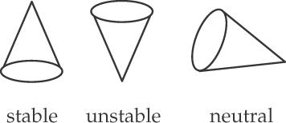

Ans. fig. p7.39

Additional Problems

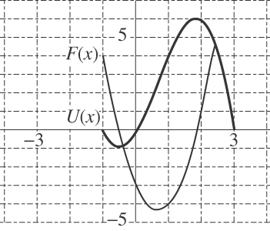P7.40 (a) 

(b) F = 0 when



ANS. FIG. P7.40

(c) The stable point is at *x* = –0.535, point of minimum U(x).

The unstable point is at  
 x = 1.87, maximum in U(x).

P7.41 **Conceptualize** Imagine the car moving to the right in Figure P7.41. When it strikes the first spring, the spring will exert a force to the left on the car. If the car is moving fast enough, it will also strike the second spring, and more force will be exerted to the left on the car. Hopefully, the car stops before the coils of the second spring press together. Otherwise, the car may simply break off the support to which the springs are attached and run off the tracks.

**Categorize** We can solve this problem using the work–kinetic energy theorem for a force that varies with position.

**Analyze** Apply the work–kinetic energy theorem to the rolling car, imagining it to come to rest just as the coils of the spring press together:



Solve for the maximum speed:



Substitute numerical values:



**Finalize** This is a relatively slow speed, so we do not want to send freight cars crashing into the device at the end of the track.

*Answer:* 0.559 m/s

P7.42 The work done by the applied force is



P7.43 We evaluate  by calculating



and



The answer must be between these two values. We may find it more precisely by using a value for  smaller than 0.100. Thus, we find the integral to be 

P7.44 Apply the work-energy theorem to the ball. The spring is initially compressed by *x*sp,*i* = *d* = 5.00 cm. After the ball is released from rest, the spring pushes the ball up the incline the distance d, doing positive work on the ball, and gravity does negative work on the ball as it travels up the incline a distance  from its starting point. Solve for 





Thus, the ball travels up the incline a distance of 0.881 m after it is released.



P7.45 (a) 



(b) 

(c) 

(d) 



(e) 



(f) 

(g) 



(h) 

P7.46 (a) The potential energy of the system at point x is given by 5 plus the negative of the work the force does as a particle feeling the force is carried from x = 0 to location x.



(b) 

P7.47 The component of the weight force parallel to the incline, *mg* sin *θ*, accelerates the block down the incline through a distance d until it encounters the spring, after which the spring force, pushing up the incline, opposes the weight force and slows the block through a distance x until the block eventually is brought to a momentary stop. The weight force does positive work on the block as it slides down the incline through total distance (d + x), and the spring force does negative work on the block as it slides through distance x. The normal force does no work. Applying the work-energy theorem,



Dividing by m, we have



Solving for x, we have



Because distance x must be positive,



For *v* = 0.750 m/s, *k* = 500 N/m, *m* = 2.50 kg, *θ* = 20.0°, and *g* =   
9.80 m/s2, we have *g*sin *θ* = (9.80 m/s2) sin 20.0° = 3.35 m/s2 and *k*/*m*   
= (500 N/m)/(2.50 kg) = 200 N/m . kg. Suppressing units, we have



P7.48 The component of the weight force parallel to the incline, *mg*sin *θ*, accelerates the block down the incline through a distance d until it encounters the spring, after which the spring force, pushing up the incline, opposes the weight force and slows the block through a distance x until the block eventually is brought to a momentary stop. The weight force does positive work on the block as it slides down the incline through total distance (d + x), and the spring force does negative work on the block as it slides through distance x. The normal force does no work.

Applying the work-energy theorem,





Dividing by m, we have



Solving for x, we have



Because distance x must be positive,



P7.49 **Conceptualize** If you pull at an upward angle on the rope, you will reduce the magnitude of the normal force and, therefore, the magnitude of the friction force, making it easier to slide the crate. Of course, that also reduces the horizontal component of your applied force, making your applied force less effective in moving the crate. There must be an optimum angle at which to pull.

**Categorize** We assume that you do not want to accelerate the crate across the floor, because that would make it harder to stop as it goes faster and faster. You want to drag the crate at a constant velocity after applying sufficient force to overcome static friction. Therefore, the crate can be modeled as a *particle in equilibrium* in both the horizontal and vertical directions.

**Analyze** (a) A free-body diagram of the crate is shown below.

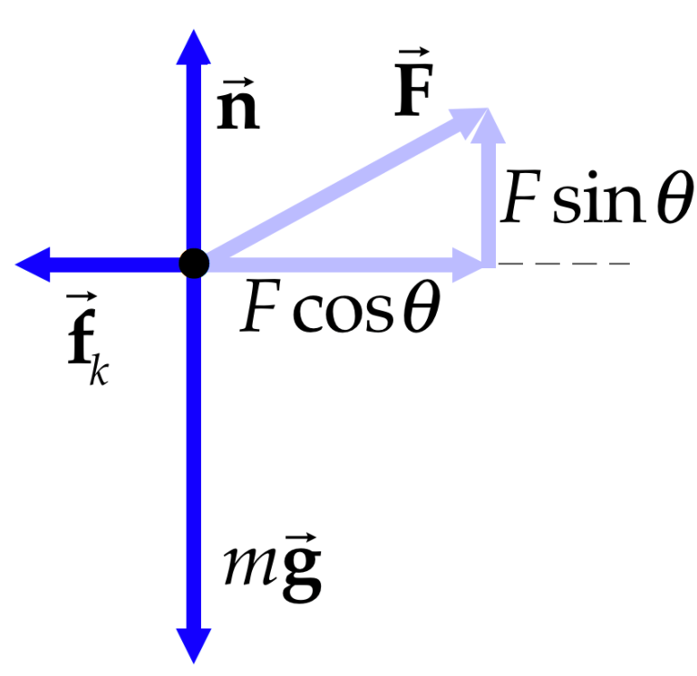

Apply the particle in equilibrium model in the vertical direction:

 (1)

Apply the particle in equilibrium model in the horizontal direction, recognizing that the friction is kinetic because the crate is sliding across the floor:

 (2)

For kinetic friction,

 (3)

Solve Equation (1) for *n* and substitute into Equation (3):

 (4)

Substitute Equation (4) into Equation (2):

 (5)

To minimize the magnitude of the force, differentiate this equation with respect to the angle ** and set the result equal to zero:



This expression equals zero if the numerator equals zero, or

 (6)

Substitute numerical values:



(b) The work you do in dragging the crate over a distance ∆*r* is given by Equation 7.1, with the help of Equation (5):



Substitute numerical values:



**Finalize** Notice that we specified in part (b) that you pull on the crate at the angle found in part (a). You can do less work on the crate by pulling at other angles. For example, if you apply a force at 90°, you will do no work at all on the crate; it will not move horizontally. But you will become very tired as you continue to do no work on the crate because you are supporting some fraction of the weight of the crate with the force you apply; your muscles will become tired. This discussion shows the difference between physical and physiological work! In reality, some physical work is done within your body, for example, as your heart pushes blood through your circulatory system to allow your muscles to apply a force.

Challenge Problems

P7.50 (a) The new length of each spring is , so its extension is  and the force it exerts is  toward its fixed end. The y components of the two spring forces add to zero. Their x components (with ) add to

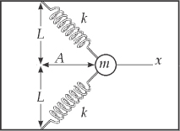

ANS. FIG. P7.50

*x*



(b) Choose U = 0 at x = 0. Then at any point the potential energy of the system is





(c) 

For negative x, U(x) has the same value as for positive x. The only equilibrium point (i.e., where *Fx* = 0) is .

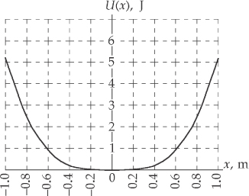  
  
aNS FIG. P7.50(c)

(d) If we consider the particle alone as a system, the change in its kinetic energy is the work done by the force of the springs on the particle:  For the entire system of particle and springs, this work is internal work and equal to the negative of the change in potential energy of the system:  From part (c), we evaluate U for x = 0.500 m:



Now find the speed of the particle:



|  |
| --- |
| **ANSWERS TO QUICK-QUIZZES** |

**1.** (a)

**2.** (c), (a), (d), (b)

**3.** (d)

**4.** (a)

**5.** (b)

**6.** (c)

**7. (i)** (c) **(ii)** (a)

**8.** (d)

|  |
| --- |
| **ANSWERS TO EVEN-NUMBERED PROBLEMS** |

P7.2 1.56 × 104 J

P7.4 method one: −4.70 × 103 J; method two: −4.70 kJ

P7.6 28.9

P7.8 (a) 11.3°; (b) 156°; (c) 82.3°

P7.10 7.37 N/m

P7.12 kg/s2

P7.14 (a) −1.23 m/s2, 0.616 m/s2; (b) −0.252 m/s2 if the force of static friction is not too large, zero; (c) 0

P7.16 (a) See ANS FIG P7.16; (b) −12.0 J

P7.18 (a) 9.00 kJ; (b) 11.7 kJ; (c) The work is greater by 29.6%

P7.20 (a) 0.600 J; (b) −0.600 J; (c) 1.50 J

P7.22 (a) 1.94 m/s; (b) 3.35 m/s; (c) 3.87 m/s

P7.24 (a) 3.78 × 10−16 J; (b) 1.35 × 10−14 N; (c) 1.48 × 10+16 m/s2; (d) 1.94 × 10−9 s

P7.26 The dart does not reach the ceiling.

P7.28 (a) , opposite to the direction of motion; (b) 1.91 × 10−4 s

P7.30 (a) UB = 0, 2.59 × 105 J; (b) UA = 0, −2.59 × 105 J, −2.59 × 105 J

P7.32 (a) , which depends only on end points, and not on the path; (b) 35.0 J

P7.34 The book hits the ground with 20.0 J of kinetic energy. The book-Earth now has zero gravitational potential energy, for a total energy of 20.0 J, which is the energy put into the system by the librarian.

P7.36 (17 - 9*x* 2*y*) i cap - (3*x*3) j cap

P7.38 (a) Fx is zero at points A, C, and E; Fx is positive at point B and negative at point D; (b) A and E are unstable, and C is stable; (c) See ANS FIG P7.38

P7.40 (a) ; (b) 1.87 and −0.535; (c) See ANS. FIG. P7.40

P7.42 

P7.44 The ball will simply stop momentarily and roll back to the spring.

P7.46 (a) U(x) = 1 + 4e-2x

(b) The force must be conservative because the work the force does on the particle on which it acts depends only on the original and final positions of the particle, not on the path between them.

P7.48 

P7.50 (a) ; (b) ; (c) See ANS. FIG. P7.50(c), *x* = 0; (d) *v* = 0.823 m/s